How to restart JIRA Windows Servers

Stop JIRA
- Log in to SUSDAY342 server as JIRA Application User JA230089.
- Click on Start
- Navigate to All Programs > JIRA
- Right-Click Stop JIRA Service [8080] and select “run as Administrator”
- Change the JIRA service to Manual.

Suspend JIRA DB Backups in SMO
- Log in to SUSDAY343 server as JIRA DB User sa230478.
- Open SMO UI
- Go to Schedule tab, Right-Click to open SMOJIRA_PRO
- Right-Click Hourly Backup and select Suspend.
- Right-Click Daily Backup and select Suspend.
- Right-Click Weekly Backup and select Suspend.
- Log out user sa230478

Change Oracle Services to Manual
- Log in to SUSDAY343 server as JIRA DB User oa230046.
- Change the following services to Manual
  - OracleServiceSMOJIRA
  - OracleServiceJIRAPRD
  - OracleOraDb11g_home1TNSListenerlistener_jiraprd
  - OracleMTSRecoveryService
  - OracleJobSchedulerSMOJIRA
  - OracleJobSchedulerJIRAPRD
  - OracleDBConsolejiraprd
  - NetApp Snapmanager 3.2 for Oracle
- Stop SMO Service “NetApp Snapmanager 3.2 for Oracle”

Disable Windows scheduled scripts
- Click start > Task Scheduler > Task Scheduler Library
- Disable All windows scheduled scripts : Right-click > Disable

1. Shutdown SMO Database
- Open command prompt as administrator.
  - Click start , Right Click cmd and select Run as Administrator
- Browse to NCR_ADMIN directory by running following commands.
  - Cd E:\susday343\ncr_admin\bin
  - E:
- Run following command to stop JIRA database
  - dbostop.bat SMOJIRA
- Wait until you see following command
  - Database SMOJIRA shutdown successfully!
- Type Exit to finish.

2. Shutdown JIRAPRD Database
- Open command prompt as administrator.
  - Click start , Right Click cmd and select Run as Administrator
- Browse to NCR_ADMIN directory by running following commands.
  - Cd E:\susday343\ncr_admin\bin
  - E:
- Run following command to stop JIRA database
  - dbostop.bat JIRAPRD
- Wait until you see following command
  - Database JIRAPRD shutdown successfully!
- Type Exit to finish

Restart SUSDAY343 Server
Restart susday343 server and after restart follow below steps
1. Start JIRAPRD Database
- Log in to SUSDAY343 server as JIRA DB User oa230046
- Open command prompt as administrator.
  - Click start , Right Click cmd and select Run as Administrator
- Browse to NCR_ADMIN directory by running following commands.
  - Cd E:\susday343\ncr_admin\bin
  - E:
- Run following command to start JIRA database
  - dbostart.bat JIRAPRD
- Wait until you see following command
  - Database JIRAPRD started successfully!
- Type Exit to finish.

To check the whether the database is started successfully, do following.

- Open command prompt as administrator.
- Enter following command
  - Set ORACLE_SID=JIRAPRD
- Start sqlplus by running following command.
  - Sqlplus / as sysdba
- In the sqlplus prompt, Enter following query.
  - Sql> select open_mode from v$database.
- The result from the step 4 should be READ WRITE.
- Enter Exit to finish.

2. Start SMOJIRA Database
- Open command prompt as administrator.
  - Click start , Right Click cmd and select Run as Administrator
- Browse to NCR_ADMIN directory by running following commands.
  - Cd E:\susday343\ncr_admin\bin
  - E:
- Run following command to start JIRA database
  - dbostart.bat SMOJIRA
- Wait until you see following command
  - Database JIRAPRD started successfully!
- Type Exit to finish.

To check the whether the database is started successfully, do following.

- Open command prompt as administrator.
- Enter following command
  - Set ORACLE_SID=SMOJIRA
- Start sqlplus by running following command.
  - Sqlplus / as sysdba
- In the sqlplus prompt, Enter following query.
  - Sql> select open_mode from v$database
- The result from the step 4 should be READ WRITE.
- Enter Exit to finish.

Change Oracle Services to Automatic/Start
- Log in to SUSDAY343 server as JIRA DB User oa230046.
- Change the following services to Automatic
  - OracleServiceSMOJIRA
  - OracleServiceJIRAPRD
  - OracleOraDb11g_home1TNSListenerlistener_jiraprd
  - OracleMTSRecoveryService
  - OracleJobSchedulerSMOJIRA
  - OracleJobSchedulerJIRAPRD
  - OracleDBConsolejiraprd
  - NetApp Snapmanager 3.2 for Oracle
- Start SMO Service “NetApp Snapmanager 3.2 for Oracle”
Make sure the STATUS of all the above services are started if not then start them.

Important: Make sure that OracleOraDb11g_home1TNSListenerlistener_jiraprd is started

Enable Windows scheduled scripts
- Click start > Task Scheduler > Task Scheduler Library
- Enable All windows scheduled scripts : Right-click > Enable

Resume JIRA DB Backups in SMO
- Log in to SUSDAY343 server as JIRA DB User sa230478.
- Open SMO UI
- Go to Schedule tab, Right-Click to open SMOJIRA_PRO
- Right-Click Hourly Backup and select Resume.
Important: If these did not show up in the tree then have to stop / start service “NetApp Snapmanager 3.2 for Oracle”
- Right-Click Daily Backup and select Resume.
- Right-Click Weekly Backup and select Resume.
- Log out user sa230478
Restart SUSDAY342 Server
Restart susday342 server and after restart follow below steps

Start JIRA
- Log in to SUSDAY342 server as JIRA Application User JA230089.
- Click on Start
- Navigate to All Programs > JIRA
- Right-Click Start JIRA Service [8080] and select “run as Administrator”
- Change the JIRA service to Automatic
- Open URL http://jira.ncr.com/rpc/soap/sharedspace-s1v1?wsdl to make sure extended soap service is working. Expected result should be following.
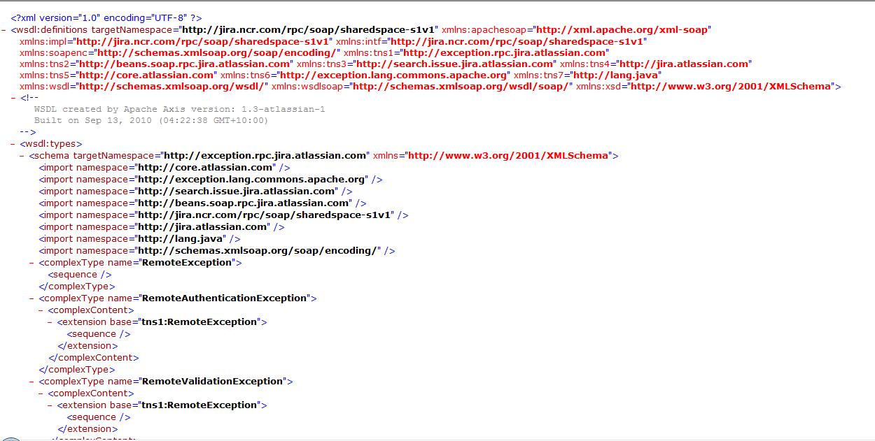
If the result is different then follow below steps
- Login to http://jira.ncr.com/secure/Dashboard.jspa using Quicklook id
- Click on Administration
- Click Plugins link
- Enter your password again
- Under User-Installed Plugins expand Jira Webservice Extensions
- Click Disable
- Click Enable Again
- Exit Administration
- Open URL http://jira.ncr.com/rpc/soap/sharedspace-s1v1?wsdl to make sure extended soap service is working.

Summary:
- Stop JIRA Application
- Suspend SMO Backups
- Disable Schedule tasks
- Change Services to manual
- Stop SMO Service
- Stop SMO DB
- Stop JIRAPRD
- Stop Oracle Services
- Restart Windows
- Start JIRAPRD
- Start SMODB
- Start Oracle Services
- Start SMO Service
- Resume SMO Backups
- Change Services to Automatic/Start
- Enable Schedule Tasks

